Experimental and Surface Complexation Modeling of Radium Sorption to Iron Oxies, Iron Sulfides, and Montmorillonites

Michael Chen and Benjamin D. Kocar

Dept of Civil and Environmental Engineering,

Massachusetts Institute of Technology

**Introduction**

Chronic ingestion and inhalation of radioactive materials, including radium (Ra) and radon (Rd), is an ongoing threat to human health worldwide [1]. Of these, Ra is ubiquitous in soils, aquifers, and natural waters owing to the radioactive decay of primordial 235-U, 238-U, and 232-Th, and often accounts for the dominant fraction of total radiation found in groundwater. All isotopes of Ra are unstable, and four (223Ra, 224Ra, 226Ra, and 228Ra) possess half-lives sufficient to persist within environmental systems and present a risk for human exposure. Moreover, 226Ra (half-life of 1600 years) is the parent radionuclide of 222Rn; chronic inhalation of 222Rn is a major driver for increased risk of lung cancer. Hence, geochemical controls on Ra mobility are directly tied to the mobility and accumulation of Rn within soil-sedimentary systems [2].

Several geochemical processes impart overarching controls on Ra within soils and aquifers. Alpha-recoil, the ejection of daughter radionuclides from soil and sedimentary minerals into adjacent porewater, is the primary process sourcing Ra to groundwater. Ongoing alpha recoil progressively elevates porewater Ra activities until hydrologic flushing removes the equilibrating solution, or Ra achieves secular equilibrium with its parent radionuclides. Most aquifer systems contain low but adequate (e.g. U, Th, <5 mg/kg) parent radionuclide and sufficiently favorable hydrological conditions to facilitate delivery of measurable Ra to solution [3]. In a recent USGS study [4], 3% of groundwater samples (n=1270) within 7 of 15 principal US aquifers exceeded the USEPA limit for total Ra of 0.185 Bq/L. Further, high levels of Ra are often present with deeper formations, particularly shales, where low groundwater flux yield potentially hazardous activities (0.102-343 Bq/L) [5]. These naturally elevated Ra bearing formations are prevalent in some parts of the US (PA, WY, TX) and abroad (Middle East, etc.) [6], [7]. Anthropogenic activities, including uranium mining and hydraulic fracturing, can redistribute Ra and other constituents of naturally occurring radioactive materials (NORM), posing potential hazard to soils, surface waters, and aquifers.

Radium isotopes are also used as naturally occurring environmental tracers. The mass balance of Ra isotopes in estuarine/near shore systems can provide estimates of subterranean groundwater discharge (SGD) [8]. This method matches well with other SGD measurements, but is unable to resolve groundwater behavior within estuarine systems [9]; non-conservative mixing and retardation may occur in these zones owing to sorption or fluctuations in pH, salinity or redox state [10]. In addition to its use as a groundwater tracer, Ra has also been identified as a marker for historic spills associated with hydrocarbon extraction [7]. This is possible if the Ra isotopic signature of produced water significantly differs from that of local groundwater, which is typical in many hydrocarbon bearing formations [11]. Successful implementation of this method requires a comprehensive accounting of Ra fate in groundwater, as transport may be significantly non-conservative due to mixing of the highly saline, often anoxic waste waters with shallow, oxic, low salinity groundwater.

While Ra transport is considered to be conservative in some groundwater systems, it nevertheless participates in geochemical reactions that may alter its subsurface distribution. The low solubility and rapid precipitation of Ra solids with any available sulfate generally do not constrain long term Ra behavior in most natural systems [1], [12]. Hence, Ra adsorption to solids, particularly mineral surfaces, imparts the greatest chemical control on soluble Ra transport in groundwater systems [10]. Under environmental conditions, Ra is not redox active, and its solution speciation is dominated by free Ra (Ra2+) across a wide range of chemical conditions (e.g. pH and salinity). Weak complexes with carbonate, sulfate, and chloride are observed, but these solution species dominate at extremely acidic or basic pH values and when ligand activities exceed environmentally relevant activities [13].

Numerous studies have examined Ra (ad)sorption to natural sediments and specific minerals by measuring and comparing distribution coefficients, Kd [12], [14]–[16]. In general, iron (hydr)oxides, manganese oxides, and some clay minerals are found to be potent sorbents of Ra [17]. Organic matter also plays an important role, but it is unclear how it compares to mineral phases [18]. Sorption of other group II ions to montmorillonites and other clay minerals is also well studied [19], but there is only a limited data set for radium sorption [20]. Lastly, there is limited study of any group II cation sorption to reduced mineral phases (mackinawite, pyrite, etc.) that are common in estuarine and other anoxic systems [21]. These phases may impart a direct control through sorption to their surfaces, or play a more sublte role as shifting redox conditions spur the formation of oxic coatings that alter aquifer Ra sorption over time. Moreover, while reported Kd values provide a useful indicator for the extent of Ra retention in a given system, these coefficients are empirical and not easily adapted to chemically dynamic and mineralogically complex systems.

In contrast, surface complexation modeling (SCM) employs mass action equations subject to thermodynamic and electrostatic constraints to describe solute-solid phase interactions. They are typically calibrated using adsorption isotherm/titration data collected across a range of geochemical conditions, sometimes with the aid of spectroscopic tools or *ab inito* modeling [22]. In general, they are used to describe and validate surface chemical reactions for specific minerals and define and estimate important surface reactions for complex mineral mixtures (e.g. soil and sediment samples). These can then facilitate predictions of solute mobility in specific aquifer systems. Challenges associated with using and comparing results of SCMs within the scientific literature include the variety of experimental systems and conditions used for model calibration, and non-standard methodology for choosing model parameters and SCM chemical reactions [23].

Although a wealth of Kd values have been tabulated for Ra adsorption to natural and synthetic solids, limited studies have used SCM to examine Ra adsorption to ferrihydrite and goethite, and at levels far exceeding those found in most environmental systems [22], [24]; SCM’s have not yet been developed for Ra adsorption to reduced iron (sulfide) or clay minerals. Therefore, the objectives of this work are to 1) examine low-activity Ra adsorption to several ubiquitous minerals known or inferred to control Ra transport over a range of solution conditions found in soils and aquifers , 2) use SCM to test mechanistic descriptions of Ra adsorption to mineral surfaces, and 3) use SCM to provide quantitative comparisons of Ra adsorption to different minerals. We choose to compare sorption of Ra to ferrihydrite, goethite, sodium montmorillonite, and pyrite within a low salinity background solution and model Ra sorption behavior through SCM. These minerals are representative of widespread, dominant sorbents found in many soil-sediment systems (Na-montmorillonite) under oxic (iron oxides), and anoxic (iron sulfide—pyrite) conditions. As expected, we find that pH plays a crucial role in determining the extent of Ra sorption to most mineral surfaces; however, we also illustrate that Ra adsorption to montmorillonite is more extensive over a range of solution conditions compared to iron (hydr)oxides, which are often thought as dominant adsorbent minerals.

**Materials and Methods**

Dissolved 226-Ra stock in 3% HCl was provided by the MIT Environmental, Health, and Safety office and used for all experiments. A ferrihydrite slurry and goethite powder were prepared using standard methods and added to the experiments [25] (SI). Powdered calcium montmorillonite STX-1b was ordered from the clay minerals society (clays.org), re-equilibrated with sodium chloride to allow for closer comparisons to previous studies of Ra sorption to Na-montmorillonites, and then cleaned of carbonates using standardized techniques [20] (SI). Pyrite was ordered from Ward’s Science (www.wardsci.com), ground using mortar and pestle, passed through sieves to select for 45-250 um particles, and transferred to an anaerobic glove bag (5% H2: 95% N2: < 1 ppm O2). It was then was washed in 6 N HCl overnight to dissolve any thin iron oxide coatings, rinsed with deoxygenated DI water three times to remove residual acid, and dried anaerobically at room temperature in an open beaker. The composition of pyrite, ferrihydrite and goethite was confirmed using XRD, and surface area was measured for all minerals using BET (table 1-SI).

Isotherms were conducted using serum vials (200 mL) filled with 100 mL of 10 mM NaCl stock solution, 30 mg of a single mineral (except for the case of pyrite, where 40 mg was used), and 5-270 Bq of 226-Ra stock. Experiments using pyrite were performed in an anaerobic glove bag, and all solutions were purged with N2 prior to placement in the anaerobic chamber. The pH was titrated to 3,5,7 or 9 +/- 0.05 through use of an autotitrator, and the bottle was sealed with a thick butyl stopper. Bottles were shaken for 24 hours to allow sufficient time for sorption equilibrium [24]. A kinetic study of Ra adsorption to montmorillonite confirmed 24 hours is sufficient to achieve equilibrium. pH was readjusted after equilibration if necessary (SI). Acid (HCl) and base (NaOH) volume additions did not exceed 5% of the original volume. Once re-titration and re-equilibration were complete, samples were filtered using 0.22 µm PES filters, which did not sorb significant quantities of Ra. Experimental error was quantified by measuring the standard deviation of triplicates for each data point.

**Analytical Techniques.** Solutions of Ra were quantified using scintillation counting. Up to 10 mL of sample were mixed with 10 mL of Ultima Gold XR (Perkin Elmer) and sealed for 30 days to allow 226-Ra to reach secular equilibrium with its daughter products. The equilibrated samples were then counted using a Beckman Coulter LS 6500 scintillation counter, and the resulting counts were compared to a calibration curve of similarly prepared 226-Ra standards to determine solution activities. This was sufficient to determine the extent of sorption and develop isotherms, with the single exception of experiments using ferrihydrite at pH 9, where gamma spectroscopy was used to quantify Ra (SI).

**Surface Complexation Modeling.** Radium binding to mineral surfaces was modeled through a double diffuse layer (DDL) surface complexation model implemented in PHREEQC [26]. Reaction formulations developed from spectroscopic measurements and used in previous studies were used to fit the experimental data [22], [24]. Further details of the SCM, full plots of modeling results, as well as results with alternative reaction formulations are provided in the supplementary information.

**Results and Discussion**

**Sorption isotherms.** All fitted isotherms were linear within the range of activities studied, and a Kd value was calculated by fitting a line to the experimental data (Table 1). The sorption isotherm results for all minerals are plotted in figure 1. Sorption to both iron oxides show a strong dependence on pH, with ferrihydrite showing greater sorption across all pH values compared to goethite, and the extent of sorption increasing with increasing pH for both iron oxides. Differences in the surface area (SI-table 1) explain some of the variation when comparing the extent of Ra sorption for goethite and ferrihydrite sorption, with ferrihydrite having nearly twice the surface area of goethite. Accordingly, A Ksa, defined as the Kd normalized by the mineral surface area (m2/g) (Table 1), is used to compare the extent of Ra adsorption between treatments. At circumneutral pH, goethite and ferrihydrite have relatively close Ksa values, however at more extreme values (pH = 3 and pH = 9), ferrihydrite demonstrates an appreciably larger extent of sorption compared to goethite. Several studies examine sorption of Ra to iron (hydr)oxides, including ferrihydrite and goethite, reporting either a K­d or data that can be used to calculate one [10], [14], [24], [27] (Table 2-SI).

Two studies report isotherm data for Ra sorption to ferrihydrite, and the experimental results presented here match both reported values to within an order of magnitude of the Kd values [24], [27]. The K­d found in our study is the largest of the collected data sets, but was also performed at lower background ionic strength (here, 10 mM, others, 100-500 mM) and higher mineral surface area (here, 382.9 m2/g, others, ~250 m2/g) , consistent with previous results suggesting increased salinity reduces the extent of Ra sorption [10]. One study compared Ra sorption to hematite, ferrihydrite, goethite, and lepidocrocite, finding that ferrihydrite sorbs Ra most extensively [27]. This suggests the sorption isotherm results presented here represent an upper limit for Ra sorption to iron oxides in these conditions.

Reported Kd values for Ra adsorption to goethite [15], [24], [27] (and experimental conditions) vary widely (SI-Table 2). Unlike results obtained for ferrihydrite, we observe a larger extent of Ra sorption at pH 7 and 9, which may be attributed to differences in solution ionic strength and surface area of the synthesized goethite. When normalized by surface area, Kd values are similar in some cases [24], but are different in others where ionic strength was much higher [27]. Although the goethite synthesized here should more closely match those found in natural settings [25], other studies used different synthesis methods that often result in lower SA. The differences between the results here and in other studies underscore the limitations of using Kd to describe and report solute-solid interactions.

Sorption isotherm results for Ra onto sodium montmorillonite are plotted in figure 1, the calculated Kd and Ksa values listed in table 1. With the exception of ferrihydrite at pH 9, the total extent of sorption to montmorillonite is larger than iron (hydr)oxides over all pH values. Also, a comparatively weaker pH dependence is observed for montmorillonite sorption. This result suggests that the dominant mechanism controlling montmorillonite sorption is not complexation with pH dependent surface (edge)functional groups, but rather exchange of Ra with ions in clay interlayer. Comparison of the measured sorption Kd values here to earlier studies reveal appreciable differences, with values spanning approximately one order of magnitude (Table 2-SI). Those using a high solid-solution ratio (3000-50000 mg/L) resulted in less sorption compared to the sorption results found here, which used only a 300 mg/L solid-solution ratio [20], [28]. The CEC of the montmorillonites are similar to that used in this experiment (within 10 meq/100 g clay), and albeit higher here, surface areas are within a factor of 3 of each other, suggesting interlayer charge is also similar. These discrepancies might explain some of the differences observed [19], however, a more detailed investigation into the sorption mechanisms at play in these clays, and the underlying clay features controlling will be necessary to understand the key factors controlling Ra sorption.

Pyrite showed limited sorption of Ra at low pH (3 and 5), but appreciable sorption at higher values, with little difference observed between isotherms performed at pH 7 and 9 (figure 1). The circumneutral and basic Kd values (table 1) for pyrite are comparable to that of goethite at a circumneutral pH. Unexpectedly, calculated Ksa values show that pyrite has the largest sorption of all of the minerals considered here. There is very little, if any existing data examining the sorption of Ra to any reduced iron solid. A previous study examining sorption of strontium to pyrite found no discernable sorption, contradicting the results found here [21]. It is unclear why this should be the case, as pyrite treatment was similar in both this study and the study of strontium. The supporting information contains a more thorough examination of this discrepancy. The results here suggest that reduced iron solids will play a key role in anoxic aquifers, where dynamic variations in redox will alter the surface mineralogy of reduced iron, either releasing Ra or enhancing Ra retention. Further investigation of surface complexation reactions may elucidate the source of this discrepancy with previous work with Sr, as well as enable predictions of Ra surface complexation with pyrite under shifting environmental conditions.

**Surface Complexation Modeling**. Radium sorption to ferrihydrite and goethite was fit using two tetradentate reactions with a single site based on SCM by Sajih, 2014, which closely simulated the experimental data (figure 2). A simpler formulation that can be compared to other studies of metal sorption was also examined but had worse visual fits (SI). The fitted reactions and constants (table 2) show that ferrihydrite and goethite have roughly similar reaction constants, but ferrihydrite has more sites, explaining why we observe more sorption extent experimentally. While the reaction constants found here are only a few log units larger than other studies’ goethite results, the constants for ferrihydrite sorption reactions here are nearly 20 log units smaller [22], [24]. Although this disparity is quite large, it is known that the structural properties (crystallinity, crystal unit size, water content) of ferrihydrite may vary substantially according to the method used for synthesis, which may account for some of the variance [29]. It is unclear though, why there would be similarities in the sorption Kd values, but such larger differences in fitted log K for surface complexation.

Concentrations of Ra used here are far below the analytical detection limits of techniques used to describe and constrain the bonding environment of Ra to solids. Hence, SCM developed here for Ra adsorption is compared with other studies that combine SCM with spectroscopic measurements, which were used to constrain surface reactions of other group 2 elements. Surface site reactions involving these other elements may have similar coordination environment and complexation reactions with solid surfaces. X-ray absorption spectroscopy was used to examine Sr binding with the surface of iron oxides, and illustrated that it forms outer sphere complexes with those surfaces [30]. A separate study used SCM informed by x-ray spectroscopy to constrain group II element sorption to iron (hydr)oxides, suggesting Ra had tetradentate coordination with iron (hydr)oxide surface sites [22], [31]. Fitted reaction constants here, and for Sr surface complexation [32], however, have not closely matched the constants predicted by that study [22]. A problem that arises when comparing SCM results is that multiple reaction formulations can satisfy the constraints developed by spectroscopic observations, without a clear indication as to which is a more accurate description of sorption or if those constraints are applicable to other elements with similar chemistry [22]. These complications, and previously discussed challenges in experimental methodology for SCM, underscore the need to make measurements of Ra sorption to mineral surfaces using the same spectroscopic techniques used for other group II elements.

Surface complexation modeling of Ra adsorption to sodium montmorillonite was fit using two surface sites and an exchange reaction where Ra displaces sodium in the inner layer of the clay, following previous SCM studies of metal sorption to montmorillonites (table 2) [19]. Fits using this model were visually good (SI-Figure X), and the exchange reaction explains the large Ra sorption extent over all pH values. A similar suite of reactions was used to describe Ba adsorption to Na-montmorillonite, and X-ray absorption spectroscopy confirmed the formation of both inner sphere and outer sphere complexes on the montmorillonite surface corresponding with the need for both an exchange reaction and surface site reactions in the SCM [33]. The number of fitted sites in this model were significantly lower than reported in the literature, with literature values producing poor fits. The presence of exchange in these models account for the significant extent of sorption at acidic pHs, however, the fitted surface complexation constants in either model also suggest that Ra binds more strongly with the clay surface than either of the iron oxides.

Although SCM has not been extensively used to examine group II cation adsorption with montmorillonites, there is a broad base of literature examining the strength of exchange and surface reactions with other metals [34]. Previously calculated metal exchange reactions with sodium montmorillonite cations show a range of values from 0.7 to 398, compared to 1.41 found here for Ra exchange. This suggests that Ra could easily be displaced by other metals in solution. Since a large fraction of the observed Ra adsorption is associated with the exchange reaction (i.e. sorption observed at low pH), this competition from other metals will likely play a large role in controlling Ra sorption to montmorillonites. In contrast, Ra had a relatively large surface complex reaction constants compared to those found for other potentially hazardous metals [19], [35]. This suggests that less competition for the protonated surface sites will occur in the presence of other metals, though it is unclear how competition between the protonated surface sites and ion exchange will control the ultimate fate of Ra in high salinity environments with many competing cations. Given the large amount of sorption associated with ion exchange, we would expect Ra would be displaced by other metals in solution.

Lastly, SCM of Ra adsorption to pyrite was performed using surficial S as the adsorption site [36] (table 2), based on a previous SCM that modeled Sr sorption to pyrite [21]. Model fits of Ra sorption capture the observed data points, though not as well as for Ra adsorption to montmorillonite or iron oxides (Figure Y - SI). The fitted reaction constant is also the lowest of all of the fitted reaction constants found here by multiple log K units. This confirms the results when comparing K­d values in between minerals, yet is contradicted by the K­sa results that showed that pyrite had the largest amount of surface area normalized sorption. Increases in the total number of surface sites in the SCM were not able to fit the experimental data accurately, which suggests that this formulation of the SCM is inaccurate with respect to the actual pyrite-Ra surface complexes. Only further spectroscopic study of Ra association with a variety of pyrite surfaces can elucidate the sorption mechanisms.

**Implications for radium as a tracer in hydrogeologic settings**

The presented experimental results and SCM highlight both preferential sorption of Ra to different mineral phases present in natural aquifers, as well as the dynamic adsorption equilibria of Ra when (bio)geochemical conditions are altered, including changes in pH, salinity, and mineralogy. This may complicate the use of Ra as a tracer of contamination or for use in other applications, including estimations of groundwater flux, particularly when total Ra activity (any isotope) is used as an important model parameter. The presence of transformable iron minerals vs relatively stable clay minerals plays a key role in determining total Ra fluxes. The results here suggest that groundwater model predictions and estimations may improve by measuring total Ra (and in some scenarios, Ra isotopes) associated with dominant subsurface minerals, and incorporating adsorption processes into simplistic mixing models.

Radium isotopes have played a crucial role in tracing the flux of groundwater into the ocean, and have been highlighted as a potential marker for investigating ground contamination resulting from hydraulic fracturing operations [7], [37]. The models used thus far are relatively simple mixing models, where transport within porous media is not considered [38]. Study of natural Ra variations showed transport plays a critical role in controlling Ra isotope concentrations, particularly the short lived isotopes Ra 223 and Ra 224, and needs more detailed models of transport to resolve these isotopes’ behavior [39]. Previous studies of Ra sorption in batch systems has provided a first basis with which to develop these models of transport, and this work contributes to these models by highlighting and comparing critical minerals that control transport, as well as providing constants and reactions to constrain Ra sorption. It also highlights areas in need of additional work to better quantify these transport processes. Investigation of Ra complexation at these surfaces, competition with redox sensitive metal ions, resolving sources of discrepancy, and further quantification of transport would be instrumental in improving Ra utility as a tracer.

[1] T. Zhang, K. Gregory, R. W. Hammack, and R. D. Vidic, “Co-precipitation of radium with barium and strontium sulfate and its impact on the fate of radium during treatment of produced water from unconventional gas extraction,” *Environ. Sci. Technol.*, vol. 48, no. 8, pp. 4596–4603, 2014.

[2] A. P. Jones, “Indoor air quality and health,” *Atmos. Environ.*, vol. 33, no. 28, pp. 4535–4564, 1999.

[3] N. Lu and C. F. V Mason, “Sorption-desorption behavior of strontium-85 onto montmorillonite and silica colloids,” *Appl. Geochemistry*, vol. 16, no. 14, pp. 1653–1662, 2001.

[4] Z. Szabo, V. T. dePaul, J. M. Fischer, T. F. Kraemer, and E. Jacobsen, “Occurrence and geochemistry of radium in water from principal drinking-water aquifer systems of the United States,” *Appl. Geochemistry*, vol. 27, no. 3, pp. 729–752, 2012.

[5] E. Barbot, N. S. Vidic, K. B. Gregory, and R. D. Vidic, “Spatial and temporal correlation of water quality parameters of produced waters from devonian-age shale following hydraulic fracturing.,” *Environ. Sci. Technol.*, vol. 47, no. 6, pp. 2562–9, Mar. 2013.

[6] A. Vengosh *et al.*, “High Naturally Occurring Radioactivity in Fossil Groundwater from the Middle East High Naturally Occurring Radioactivity in Fossil Groundwater from the Middle East,” *Environ. Sci. Technol.*, vol. 43, pp. 1769–1775, 2009.

[7] N. Lauer and A. Vengosh, “Age Dating Oil and Gas Wastewater Spills Using Radium Isotopes and Their Decay Products in Impacted Soil and Sediment,” *Environ. Sci. Technol. Lett.*, p. acs.estlett.6b00118, 2016.

[8] W. S. Moore, “Sources and fluxes of submarine groundwater discharge delineated by radium isotopes,” *Biogeochemistry*, vol. 66, no. 1, pp. 75–93, 2003.

[9] B. Burnett *et al.*, “Assessing methodologies for measuring groundwater discharge to the ocean,” *Eos, Trans. Am. Geophys. Union*, vol. 83, no. 11, p. 117, 2002.

[10] M. E. Gonneea, P. J. Morris, H. Dulaiova, and M. a. Charette, “New perspectives on radium behavior within a subterranean estuary,” *Mar. Chem.*, vol. 109, no. 3–4, pp. 250–267, 2008.

[11] N. R. Warner, C. a. Christie, R. B. Jackson, and A. Vengosh, “Impacts of shale gas wastewater disposal on water quality in Western Pennsylvania,” *Environ. Sci. Technol.*, vol. 47, pp. 11849–11857, 2013.

[12] S. Fesenko, F. Carvalho, P. Martin, W. S. Moore, and T. Yankovich, “Radium in the Environment,” 2014.

[13] M. Grivé, L. Duro, E. Colàs, and E. Giffaut, “Thermodynamic data selection applied to radionuclides and chemotoxic elements: An overview of the ThermoChimie-TDB,” *Appl. Geochemistry*, vol. 55, pp. 85–94, Apr. 2015.

[14] P. Beneš, P. Strejc, Z. Lukavec, and Z. Borovec, “Interaction of radium with freshwater sediments and their mineral components. I.,” *J. Radioanal. Nucl. Chem. Artic.*, vol. 82, no. 2, pp. 275–285, May 1984.

[15] I. Nirdosh, W. Trembley, and C. Johnson, “Adsorption-desorption studies on the 226Ra-hydrated metal oxide systems,” *Hydrometallurgy*, vol. 24, no. 2, pp. 237–248, 1990.

[16] L. Ames, J. McGarrah, and B. Walker, “Sorption of trace constituents from aqueous solutions onto secondary minerals. II. Radium,” *Clays Clay Miner.*, vol. 31, no. 5, pp. 335–342, 1983.

[17] E. R. Landa and D. F. Reid, “Sorption of radium-226 from oil-production brine by sediments and soils,” *Environ. Geol.*, vol. 5, no. 1, pp. 1–8, 1983.

[18] D. J. Greeman, A. W. Rose, J. W. Washington, R. R. Dobos, and E. J. Ciolkosz, “Geochemistry of radium in soils of the Eastern United States,” *Appl. Geochemistry*, vol. 14, no. 3, pp. 365–385, 1999.

[19] M. H. Bradbury and B. Baeyens, “Modelling the sorption of Mn(II), Co(II), Ni(II), Zn(II), Cd(II), Eu(III), Am(III), Sn(IV), Th(IV), Np(V) and U(VI) on montmorillonite: Linear free energy relationships and estimates of surface binding constants for some selected heavy metals and actinide,” *Geochim. Cosmochim. Acta*, vol. 69, no. 4, pp. 875–892, 2005.

[20] S. Tamamura, T. Takada, J. Tomita, S. Nagao, K. Fukushi, and M. Yamamoto, “Salinity dependence of 226Ra adsorption on montmorillonite and kaolinite,” *J. Radioanal. Nucl. Chem.*, vol. 299, no. 1, pp. 569–575, Sep. 2013.

[21] A. Naveau, F. Monteil-Rivera, J. Dumonceau, H. Catalette, and E. Simoni, “Sorption of Sr(II) and Eu(III) onto pyrite under different redox potential conditions,” *J. Colloid Interface Sci.*, vol. 293, no. 1, pp. 27–35, 2006.

[22] D. A. Sverjensky, “Prediction of the speciation of alkaline earths adsorbed on mineral surfaces in salt solutions,” *Geochim. Cosmochim. Acta*, vol. 70, no. 10, pp. 2427–2453, 2006.

[23] T. A. Duster, “An Integrated Approach to Standard Methods, Materials, and Databases for the Measurements Used To Develop Surface Complexation Models,” *Environ. Sci. Technol.*, vol. 50, no. 14, pp. 7274–7275, 2016.

[24] M. Sajih *et al.*, “Adsorption of radium and barium on goethite and ferrihydrite: A kinetic and surface complexation modelling study,” *Geochim. Cosmochim. Acta*, vol. 146, pp. 150–163, Dec. 2014.

[25] U. Schwertmann and R. Cornell, *Iron Oxides in the Laboratary*. Weinheim, Germany: Wiley-VCH Verlag GmbH, 2000.

[26] D. L. Parkhurst and C. A. J. Appela, “Description of Input and Examples for PHREEQC Version 3 — A Computer Program for Speciation , Batch-Reaction , One-Dimensional Transport , and Inverse Geochemical Calculations Chapter 43 of,” 2013.

[27] A. J. Beck and M. a. Cochran, “Controls on solid-solution partitioning of radium in saturated marine sands,” *Mar. Chem.*, vol. 156, pp. 38–48, Oct. 2013.

[28] L. L. Ames, “Sorption of Trace Constituents from Aqueous Solutions onto Secondary Minerals. I. Uranium,” *Clays Clay Miner.*, vol. 31, no. 5, pp. 321–334, 1983.

[29] F. M. Michel *et al.*, “The structure of ferrihydrite, a nanocrystalline material.,” *Science*, vol. 316, no. 5832, pp. 1726–9, Jun. 2007.

[30] N. Sahai, S. A. Carroll, S. Roberts, and P. A. O’Day, “X-Ray Absorption Spectroscopy of Strontium(II) Coordination,” *J. Colloid Interface Sci.*, vol. 222, no. 2, pp. 198–212, 2000.

[31] P. Fenter, L. Cheng, S. Rihs, M. L. Machesky, M. J. Bedzyk, and N. C. Sturchio, “Electrical Double-Layer Structure at the Rutile-Water Interface as Observed in Situ with Small-Period X-Ray Standing Waves.,” *J. Colloid Interface Sci.*, vol. 225, pp. 154–165, 2000.

[32] S. a Carroll, S. K. Roberts, L. J. Criscenti, and P. a O’Day, “Surface complexation model for strontium sorption to amorphous silica and goethite.,” *Geochem. Trans.*, vol. 9, p. 2, 2008.

[33] P. C. Zhang, P. V. Brady, S. E. Arthur, W. Q. Zhou, D. Sawyer, and D. A. Hesterberg, “Adsorption of barium(II) on montmorillonite: An EXAFS study,” *Colloids Surfaces A Physicochem. Eng. Asp.*, vol. 190, no. 3, pp. 239–249, 2001.

[34] M. H. Bradbury, B. Baeyens, H. Geckeis, and T. Rabung, “Sorption of Eu(III)/Cm(III) on Ca-montmorillonite and Na-illite. Part 2: Surface complexation modelling,” *Geochim. Cosmochim. Acta*, vol. 69, no. 23, pp. 5403–5412, 2005.

[35] L. Gorgeon, “Contribution à la Modélisation Physico-Chimique de la Retention de Radioéléments à Vie Longue par des Matériaux Argileux,” Universite Paris, 1994.

[36] R. Murphy and D. Strongin, “Surface reactivity of pyrite and related sulfides,” *Surf. Sci. Rep.*, vol. 64, no. 1, pp. 1–45, Jan. 2009.

[37] M. J. Lambert and W. C. Burnett, “Submarine groundwater discharge estimates at a Florida coastal site based on continuous radon measurements,” *Biogeochemistry*, vol. 66, no. 1–2, pp. 55–73, 2003.

[38] Rama and W. S. Moore, “Using the radium quartet for evaluating groundwater input and water exchange in salt marshes,” *Geochim. Cosmochim. Acta*, vol. 60, no. 23, pp. 4645–4652, Dec. 1996.

[39] A. L. H. Hughes, A. M. Wilson, and W. S. Moore, “Groundwater transport and radium variability in coastal porewaters,” *Estuar. Coast. Shelf Sci.*, vol. 164, pp. 94–104, Oct. 2015.

Table 1: Calculated Sorption Constants

|  |  |  |  |
| --- | --- | --- | --- |
| Mineral | pH | Kd (mL/g) | Ksa (mL/m2) |
| Ferrihydrite | 3  5  7  9 | 229.9  471.4  2487  115900 | 0.600  1.231 6.495  302.8 |
| Goethite | 3  5  7  9 | 0  302.7  573.6  11670 | 0  2.067  3.917  76.87 |
| Sodium Montmorillonite | 3  5  7  9 | 6740  17750  21470  22890 | 134.4  353.8  428.1  456.4 |
| Pyrite | 3  5  7  9 | 0  0  536  520 | 0  0  7825  7591 |

Table 2: Literature SCM reactions and fitted parameters

|  |  |  |  |
| --- | --- | --- | --- |
| Reactions | Sites (mol/g) | log K | Source |
| Ferrihydrite  ≡FhyOH + H+ = ≡FhyOH2+  ≡FhyOH = ≡FhyO- + H+  4≡FhyOH + Ra2+ = ≡(FhyOH)3­FhyORa+ + H+  4≡FhyOH + Ra2+ + 2H+= ≡(FhyOH2)2­(FhyOH)2Ra4+ | 1.75E-3 | 7.92  -8.93  -1.4  0 | [24]  [24]  [24]  Fitting  Fitting |
| Goethite  ≡GoeOH + H+ = ≡GoeOH2+  ≡GoeOH = ≡GoeO- + H+  4≡GoeOH +Ra2+ = ≡(GoeOH)3GoeORa+  4≡GoeOH + Ra2+ = ≡(GoeOH)4Ra2+ | 6.4E-5 | 4.8  -10.4  -2.9  4.6 | [22]  [22]  [22]  Fitting  Fitting |
| Sodium Montmorillonite  2 ≡Clay-Na + Ra2+ = ≡Clay2-Ra + 2 Na+  ≡ClayAOH + H+ = ClayAOH2+  ≡ClayAOH = ≡ClayA- + H+  ≡ClayBOH + H+ = ClayBOH2+  ≡ClayBOH = ≡ClayB- + H+  ≡ClayAOH + Ra2+ = ≡ClayAORa+ + H+  ≡ClayBOH + Ra2+ = ≡ClayBOHRa2+ | Exch: 8.43E-4  Site A: 2E-7  Site B: 6.33E-7 | 0.15  4.5  -7.9  4.5  -7.9  0  7.5 | Clays.org CEC, fitting surface sites  [34]  [34]  [34]  [34]  Fitting  Fitting |
| Pyrite  ≡PyrSH = ≡PyrS- + H+  ≡PyrS- + Ra2+ = ≡PyrSRa+ | 2.23E-5 | 6.45  -10.5 | [21]  [21]  Fitting |

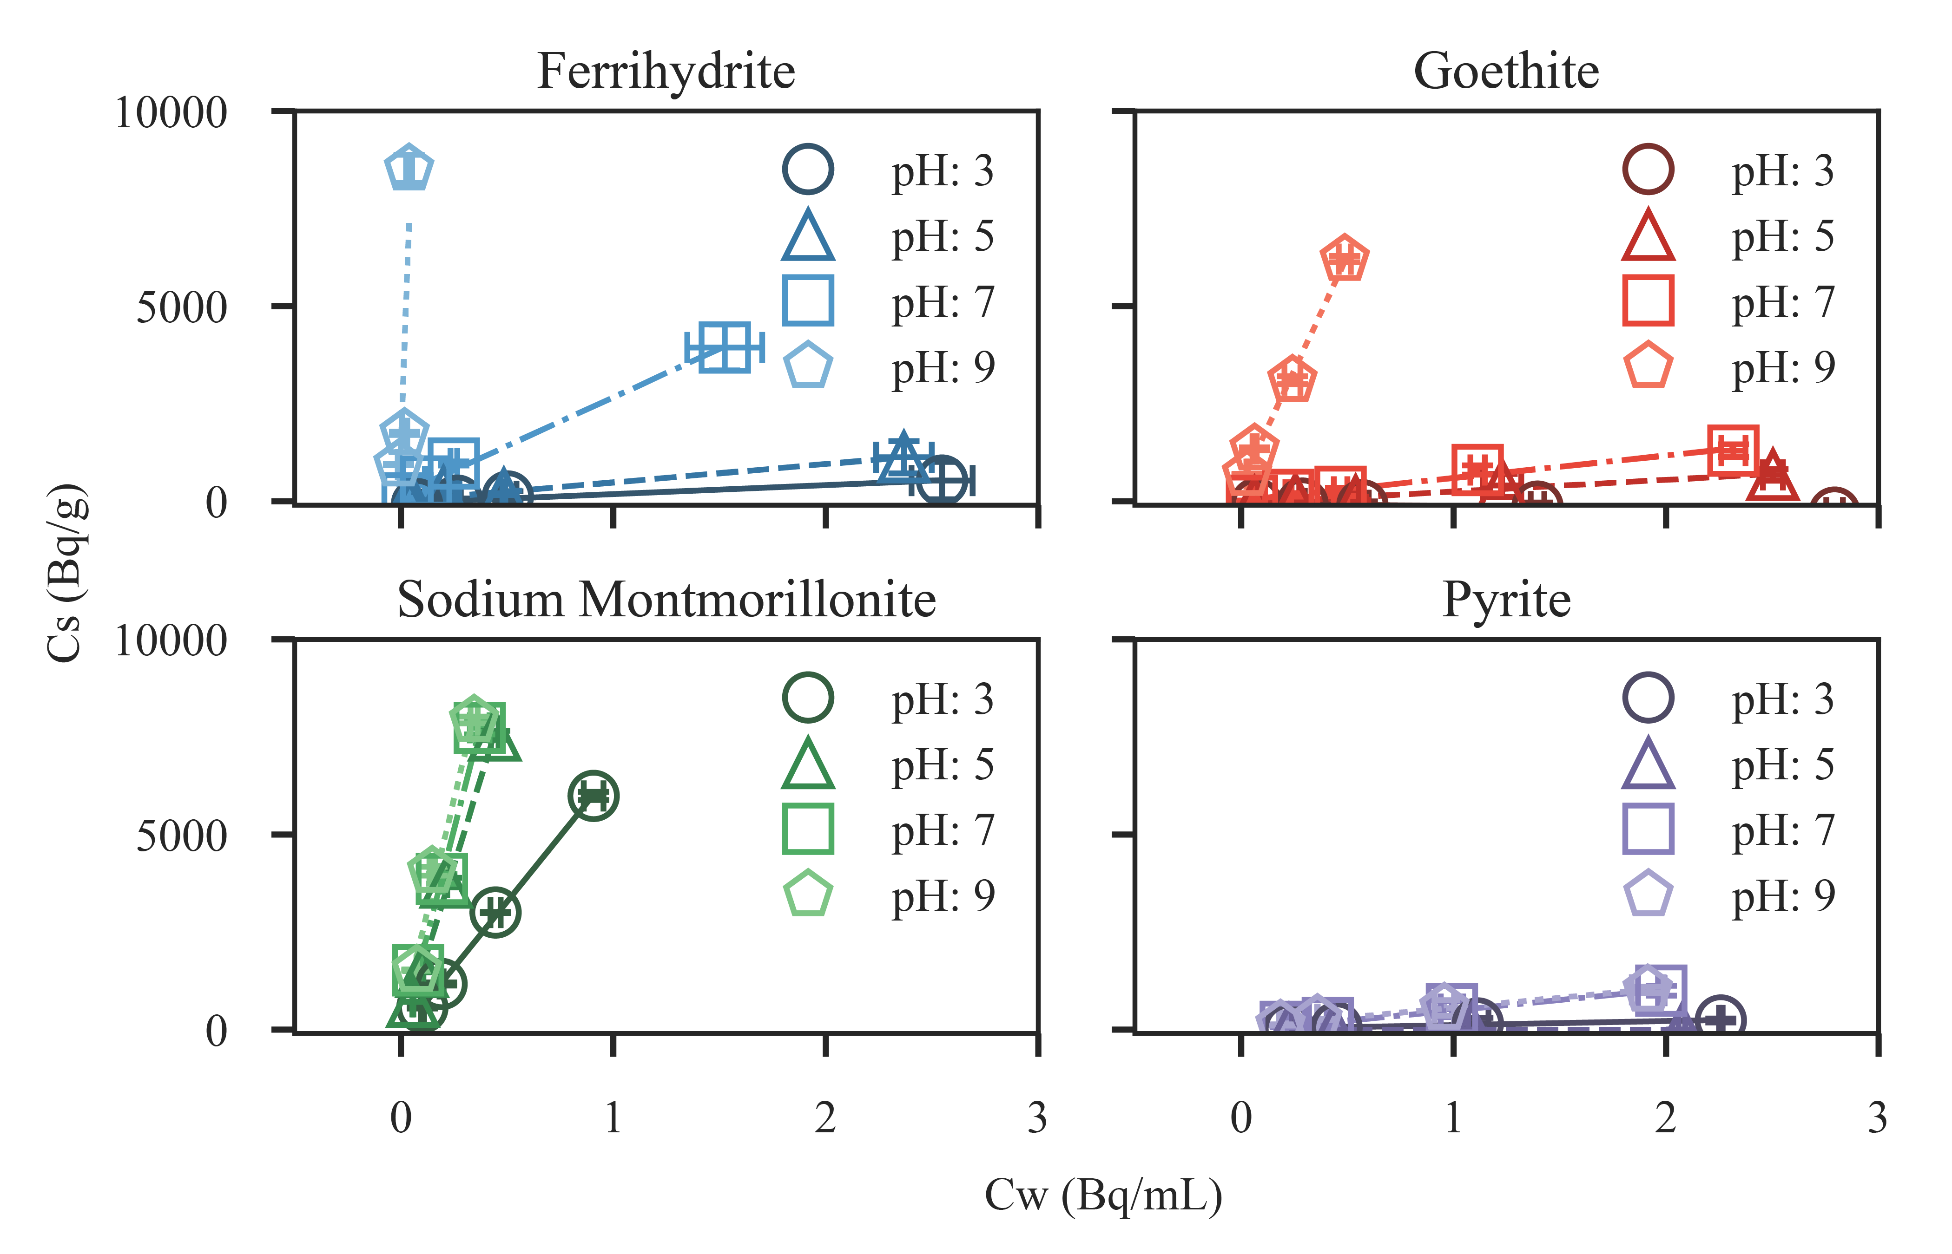**Figure 1:** Isotherm results for the studied minerals. Error bars represent the standard deviation of the triplicate measurement. Fit lines’ slope matches the measured Kd values reported in Table 1.

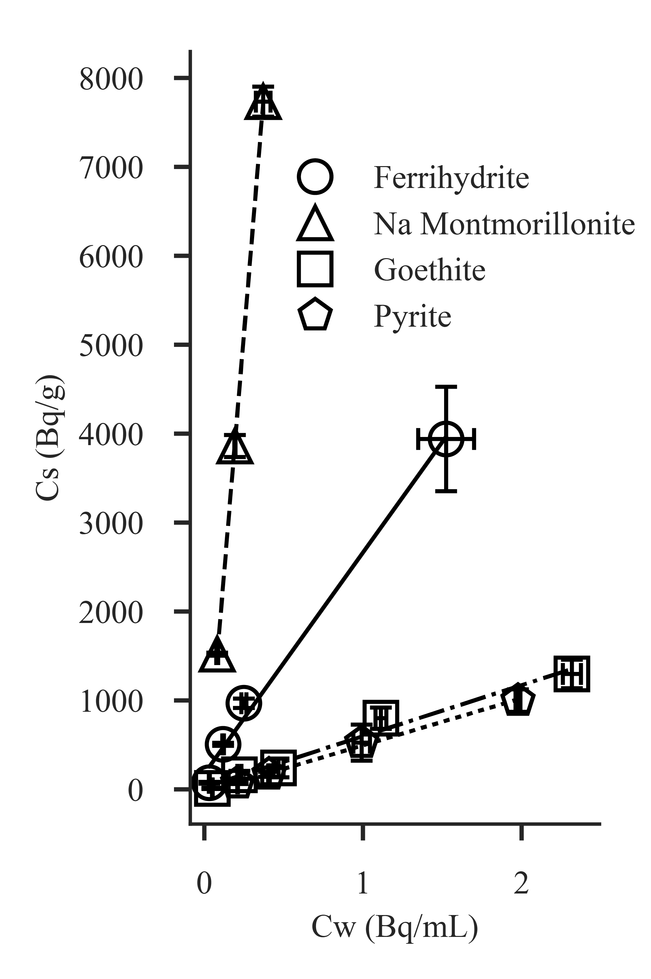

**Figure 1:** Sorption isotherm results for pH 7. Error bars represent the standard deviation of triplicate measurements, and fit lines’ slope the reported Kd values in Table 1.

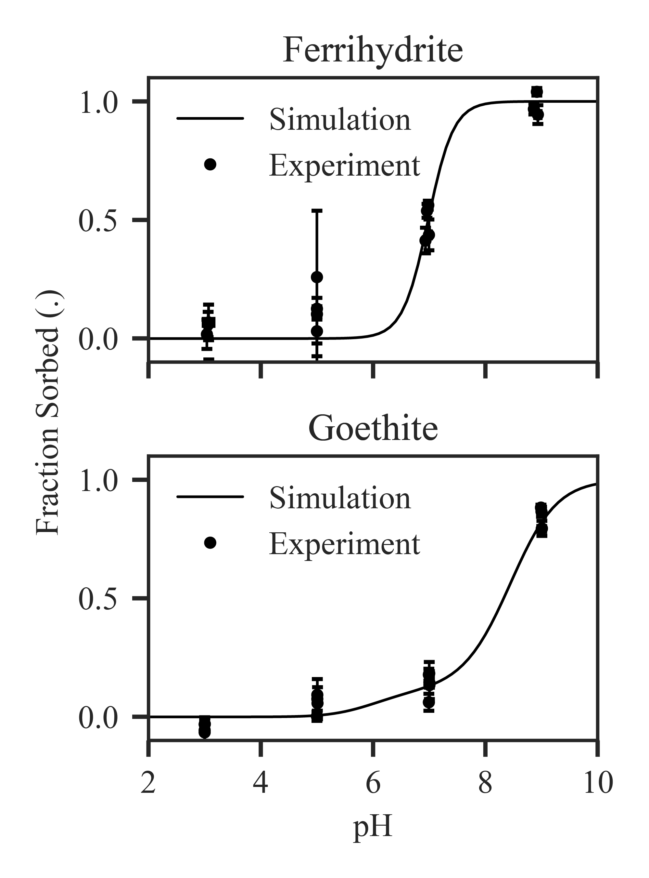

**Figure 2:** SCM results compared against experimental results for ferrihydrite and goethite. Error bars on data points represent standard deviation of triplicate experimental measurements.